الجمهورية اللبنانية
الاسم والشهرة:--------------------

رقم المرشح :----------------------
وزارة التربية والتعليم العالي الامتحانات الرسمية لشهادة الامتياز الفني
المديرية العامة للتعليم المهني والتقني لدورة عام 2015 الثانية
===============
الاختصاص والرمز : المعلوماتية الادارية ( 23104)
المادة : برمجة ويب Web المعدل: (10)
المستندات المسموح بها : لا شيء المدة : ساعتان

- Write the appropriate HTML and JAVASCRIPT tags to obtain as result the following page, that calculates the price of a meal, while respecting the following conditions: (4 pts)
- « Plat » Combo box to select a value among two: “Chicken” or “Meat”. If you select “Chicken” the price of a Plat will be 10$, if you select “Meat” the price will be 15$.
- « persons » Entry field of 4 characters. This field must contain a value greater than 0, the test should be done according to a function when we click outside the field.
- « Dessert » Combo box to select a value among two: “Ice cream” or “Cake”. If you select “Ice cream” the price of a dessert will be 3$, if you select “Cake” the price will be 5$.
- « persons » Entry Field of 4 characters. This field must contain a value greater than 0, the test should be done according to a function when we click outside the field.
- « Commander » a button that executes a function that calculates and displays the total price in the field « Price » as shown in the form below.
The total is calculated as follow: Plat price * number of persons + Dessert Price * number of persons.

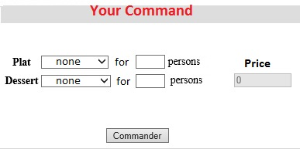
- Write the appropriate HTML tags to create the following page, by using appropriate CSS properties to keep the page formatting and layout as follow: (4 pts)
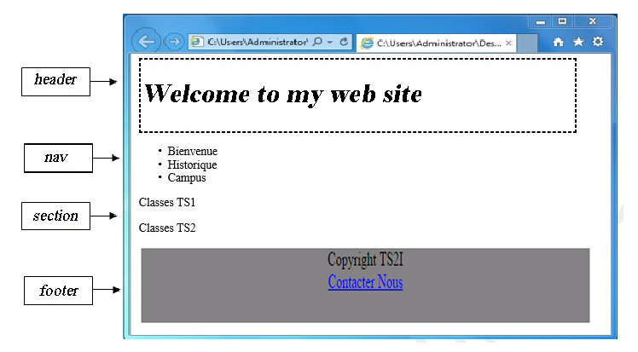
- This page contains 4 structure elements.
- The « header » and « footer » parts have the following characteristics :

header | footer
- Width: 600 pixels.  - Height: 100 pixels.  - Border: 2 pixels.  - Border style: « dashed ». | - Width: 600 pixels.  - Height: 100 pixels.  - Background color: gray.  - Text alignment: center.

الاختصاص والرمز : المعلوماتية الادارية ( 23104) المادة : برمجة ويب Web
- Write the appropriate HTML tags to obtain the following page : (5 pts)
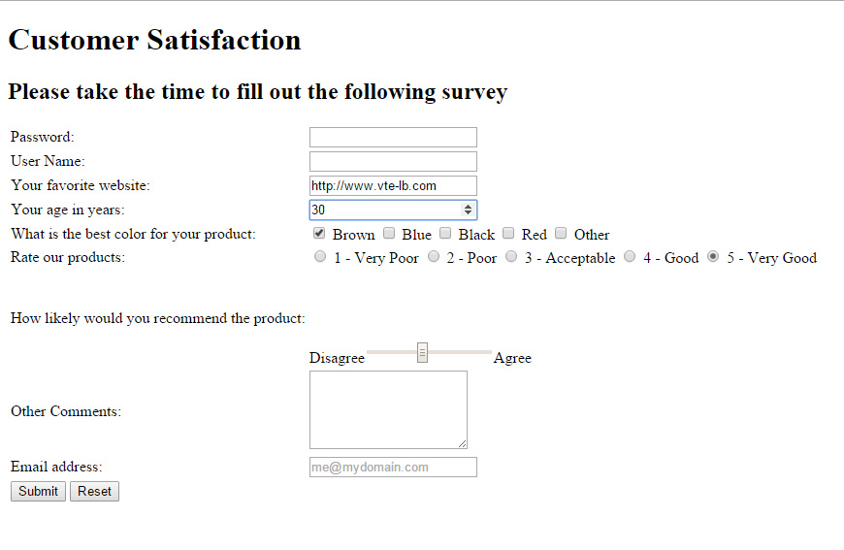
- Password: Input field "password", 40 visible characters, and maximum 256 characters.
- User Name: Input field, 40 visible characters, and maximum 256 characters.
- Indicate the appropriate type for each of the following fields: Web site, Email.
- Age: Input field "number" with default value 30, the biggest number that can be reached is 99.
- Color: Checkbox, many choices are acceptable.
- Rate our products: Radio button only one choice is acceptable.
- Disagree/Agree: is a range between 1 and 10, default value is 5.
- Other Comments: Input field, 3 rows and 40 characters.
- A button Submit to send data to: "www.mysite.com/select.php" using the post method.
- A button Reset to reset all values.

- By using "SVG" or "Canvas", write the appropriate tags to draw the circle in the following page: (2 pts)

The circle characteristics are:
- The left position of the center: 60 - The top position of the center: 40
- The radius is 40 pixels.

- Write the corresponding HTML tags to obtain as result the following page by using appropriate CSS properties to keep the page formatting and layout as follow: (5 pts)
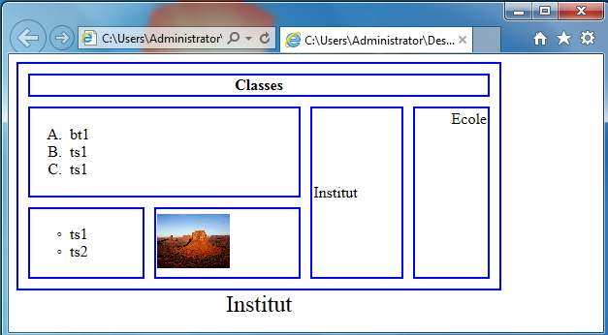
- The table title: "Institut", title size : 24 pixels
- The table has the following characteristics:
- Width: 500 pixels.
- Height: 50 pixels.
- Space between borders: 10 pixels.
- Round borders: 2 pixels.
- The table and cells border thickness is 2 pixels, having a blue color. (Use RGB, RGBa or hexadecimal code)
- The image name is “dessert.jpg” and have the following characteristics:
- Width: 75 pixels.
- The message ”Welcome” must be displayed instead of the image if there is an error.
- A click on this image sends an email towards "ts2@site.com.lb".
- The used bullets and numbers are lists.

